Introduction to Agile and Scrum

Agile software development refers to software development methodologies centered around the idea of iterative development, where requirements and solutions evolve through collaboration between self-organizing cross-functional teams. The ultimate value in Agile development is that it enables teams to deliver value faster, with greater quality and predictability, and greater aptitude to respond to change. Scrum and Kanban are two of the most widely used Agile methodologies. Below are the most frequently asked questions around Agile and Scrum, answered by our experts.

What is Agile?
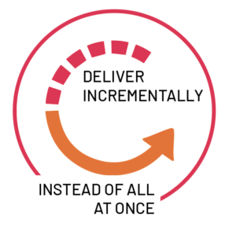
Agile software development refers to a group of software development methodologies based on iterative development, where requirements and solutions evolve through collaboration between self-organizing cross-functional teams. Agile methods or Agile processes generally promote a disciplined project management process that encourages frequent inspection and adaptation, a leadership philosophy that encourages teamwork, self-organization and accountability, a set of engineering best practices intended to allow for rapid delivery of high-quality software, and a business approach that aligns development with customer needs and company goals. Agile development refers to any development process that is aligned with the concepts of the Agile Manifesto. The Manifesto was developed by a group of fourteen leading figures in the software industry, and reflects their experience of what approaches do and do not work for software development. Read more about the Agile Manifesto. Did you know that Agile can also be applied to hardware projects? Learn about Cprime’s revolutionary Agile for Hardware framework.

What is Scrum?
Scrum is a subset of Agile. It is a lightweight process framework for agile development, and the most widely-used one.
- A “process framework” is a particular set of practices that must be followed in order for a process to be consistent with the framework. (For example, the Scrum process framework requires the use of development cycles called Sprints, the XP framework requires pair programming, and so forth.)
- “Lightweight” means that the overhead of the process is kept as small as possible, to maximize the amount of productive time available for getting useful work done.
A Scrum process is distinguished from other agile processes by specific concepts and practices, divided into the three categories of Roles, Artifacts, and Time Boxes. These and other terms used in Scrum are defined below. Scrum is most often used to manage complex software and product development, using iterative and incremental practices. Scrum significantly increases productivity and reduces time to benefits relative to classic “waterfall” processes. Scrum processes enable organizations to adjust smoothly to rapidly-changing requirements, and produce a product that meets evolving business goals. An agile Scrum process benefits the organization by helping it to
- Increase the quality of the deliverables
- Cope better with change (and expect the changes)
- Provide better estimates while spending less time creating them
- Be more in control of the project schedule and state
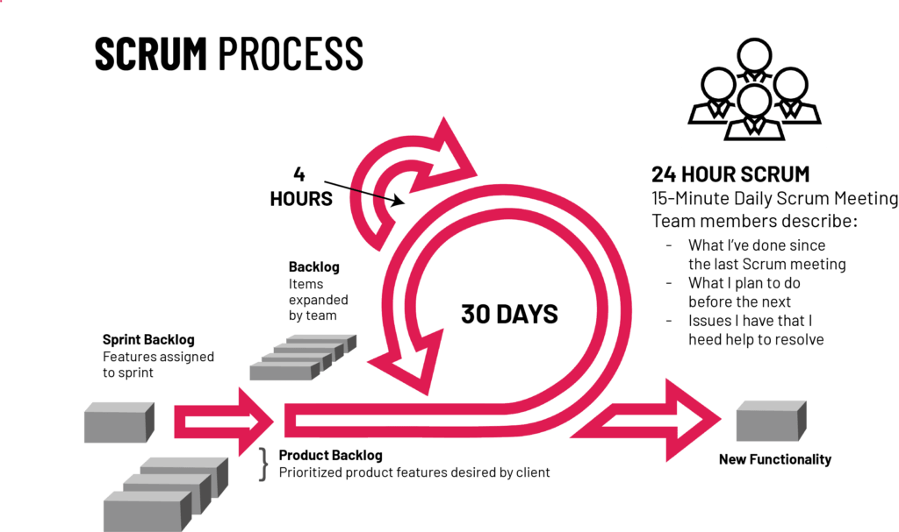

What are the benefits of Agile?
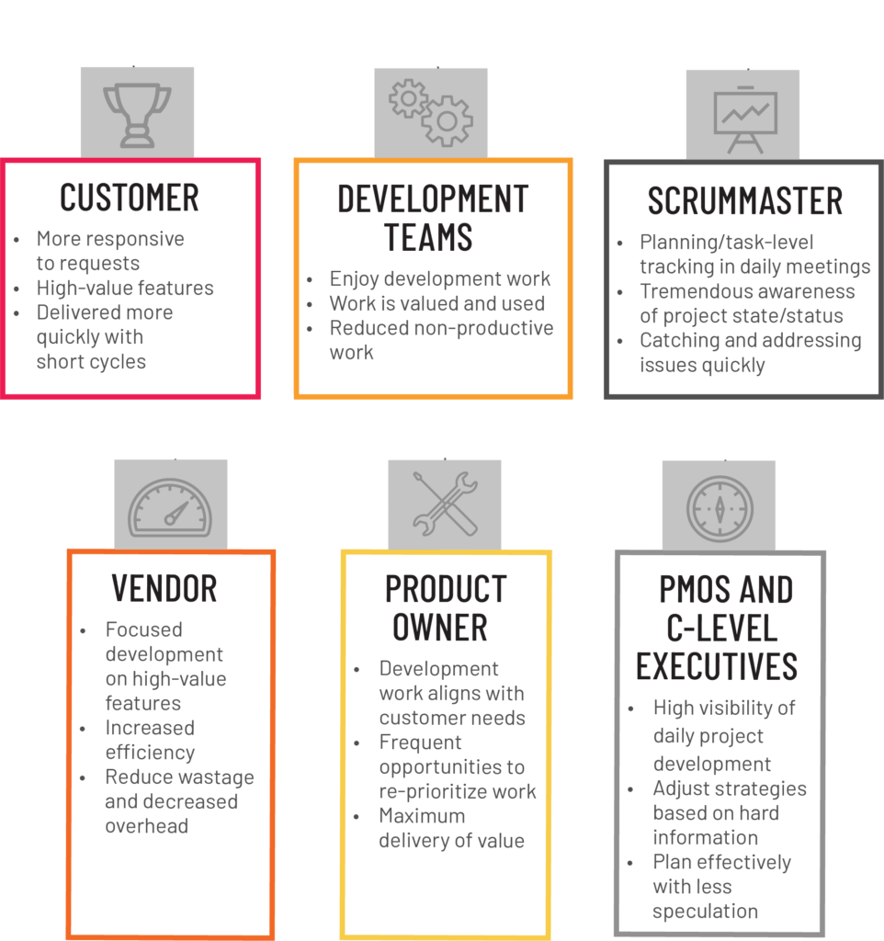

Benefits to Customer
Customers find that the vendor is more responsive to development requests. High-value features are developed and delivered more quickly with short cycles, than with the longer cycles favored by classic “waterfall” processes.

Benefits to Vendors
Vendors reduce wastage by focusing development effort on high-value features, and reduce time-to-market relative to waterfall processes due to decreased overhead and increased efficiency. Improved customer satisfaction translates to better customer retention and more positive customer references.

Benefits to Development Teams
Team members enjoy development work, and like to see their work used and valued. Scrum benefits Team members by reducing non-productive work (e.g., writing specifications or other artifacts that no one uses), and giving them more time to do the work they enjoy. Team members also know their work is valued, because requirements are chosen to maximize value to customers.

Benefits to Product Managers
Product Managers, who typically fill the Product Owner role, are responsible for making customers happy by ensuring that development work is aligned with customer needs. Scrum makes this alignment easier by providing frequent opportunities to re-prioritize work, to ensure maximum delivery of value.

Benefits to Project Managers
Project Managers (and others) who fill the ScrumMaster role find that planning and tracking are easier and more concrete, compared to waterfall processes. The focus on task-level tracking, the use of Burndown Charts to display daily progress, and the Daily Scrum meetings, all together give the Project Manager tremendous awareness about the state of the project at all times. This awareness is key to monitoring the project, and to catching and addressing issues quickly.

Benefits to PMOs and C-Level Executives
Scrum provides high visibility into the state of a development project, on a daily basis. External stakeholders, such as C-Level executives and personnel in the Project Management Office, can use this visibility to plan more effectively, and adjust their strategies based on more hard information and less speculation.

What are the Scrum requirements?
Scrum does not define just what form requirements are to take, but simply says that they are gathered into the Product Backlog, and referred to generically as “Product Backlog Items,” or “PBIs” for short. Given the time-boxed nature of a Sprint, we can also infer that each set should require significantly less time to implement than the duration of the Sprint. Most Scrum projects borrow the “XP” (Extreme Programming) practice of describing a feature request as a “User Story,” although a minority uses the older concept of a “Use Case.” We will go with the majority view here, and describe three reasonably-standard requirements artifacts found in Product Backlogs.
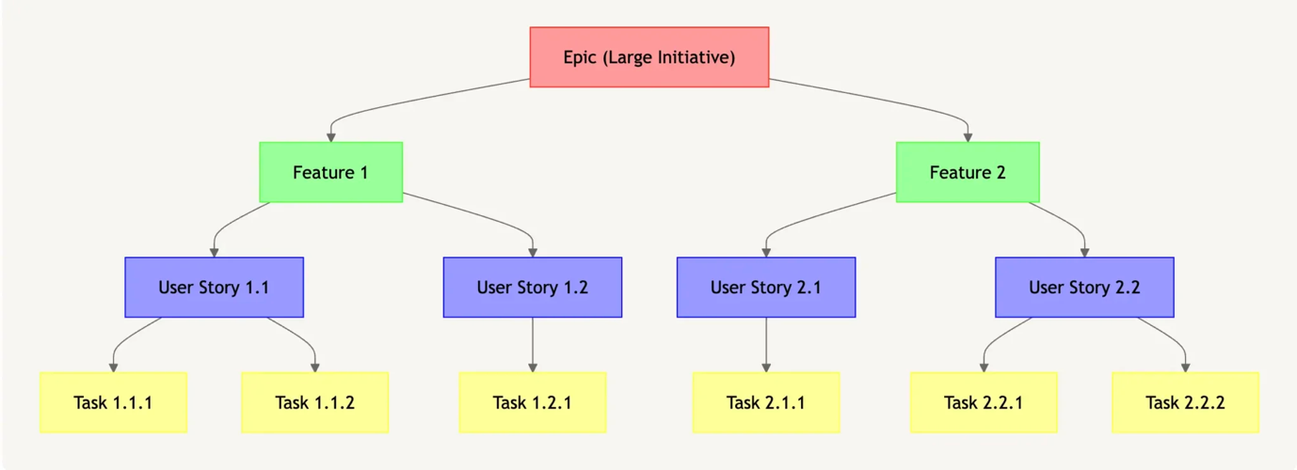

What is an epic?
An epic is a large body of work that can be broken down into smaller tasks or stories. It represents a significant, high-level initiative or goal for the product.
- Epics typically include multiple features and often span multiple sprints.
- Epics are used to capture big-picture objectives and strategic initiatives that require a lot of effort and resources to complete.
- They provide a way to prioritize and plan work at a high level and help stakeholders understand the overall direction and scope of the product.

How to Write an Agile Epic
Explaining a large, high-level initiative or goal in a way that’s concise and easy to understand can be a challenge. Here are a few tips to help you get started:
- Understand the scope: Before writing the epic, ensure you have a clear understanding of the scope and objectives. Discuss with stakeholders, product owners, and team members to decide what your overarching goal will be.
- Write your epic first: It may seem obvious, but don’t forget to set your goals before working on features or user stories.
- Use a template or format: You can treat an epic a little bit like a user story. Including certain key elements for each epic will help you keep organized. Consider including:
  - Title: A descriptive title will cut down on confusion later on.
  - Description: A brief overview of the initiative, including its purpose, objectives, and any relevant context will allow your team to understand the goal more clearly.
  - Acceptance criteria: Include high-level criteria that let you know when the epic will be considered complete or successful.
  - Dependencies: It helps to add in dependencies or prerequisites that need to be addressed for the epic to be implemented.
  - User story: If it’s helpful, you can even create an epic user story that hits on the overall goal. For instance, “As a new user, I want an onboarding experience that guides me through the platform’s features to help me get started effectively.”
- Focus on value: Ensure that the epic delivers value to the end user or contributes to the overall goals of the product.
- Keep it flexible: Epics are not set in stone and may evolve over time as more information becomes available or as priorities change. Keep the epic flexible and be open to revising or refining it based on feedback and new insights.
- Collaborate: Writing epics should be a collaborative effort involving key stakeholders, product owners, and team members. Encourage open communication and feedback to ensure that everyone understands the epic and its objectives.

Example of an Agile Epic
Title: Onboarding Experience for New Users
Description: As a new user joining our platform, I want the onboarding experience to be informative and intuitive, guiding me through the key features and functionalities to help me get started effectively. By enhancing the onboarding experience, we aim to reduce the learning curve for new users, increase user engagement, and foster a positive first impression of our platform.
Acceptance Criteria:
- New users are greeted with a personalized welcome message upon signing up, providing a brief overview of the platform’s capabilities.
- Interactive tutorials are available to guide new users through the key features and functionalities, allowing them to learn at their own pace.
- Tooltips are strategically placed throughout the platform to provide contextual guidance on how to perform specific actions or tasks.
- The onboarding experience is customizable to accommodate users with different levels of expertise and preferences.
- User feedback mechanisms are in place to gather insights on the effectiveness of the onboarding experience and identify areas for improvement.

What is feature?
Epics get broken down into smaller pieces of a work, called features. The epic is at the top of the hierarchy, and the features are the parts that’ll make the overall epic happen. Think of a feature as a smaller offshoot of its epic, like one branch on a tree. That branch is part of the larger plant and helps make up the whole.
- Usually, a feature is a concrete, actionable item, whereas an epic is an overarching goal.
- While an epic can take several sprints to complete, a feature can usually be implemented within one to three sprints.
- Features are more detailed than epics. That’s because features key into a particular objective or address a specific user need. Epics can focus on the bigger picture, whereas features have to lay out the details that will help team members understand what needs to be built.
- You have to be able to test a feature and have some idea what the feature must do to pass the test and be valuable to the customer.
- Features often correspond to user stories, which we’ll get into more deeply below.

How to Write a Feature
Describing a feature requires a whole different set of details. Here’s what you should include:
- Identify the purpose: What’s the point of this feature? How does it match the goals you set out in your epic?
- Define the scope: As you did with your epic, be sure you include what your feature will and will not include. Consider any dependencies or prerequisites that may affect implementation, too.
- Describe the benefit: Write a short description that tells the reader what the feature will deliver. Focus on what the feature will let users do or accomplish within the product.
- Set out acceptance criteria: What has to happen before the feature can be considered complete and ready for release? These criteria should lay out the specific behaviors or outcomes that will demonstrate success.
- Prioritize: Prioritize the feature based on its importance to the end user and the business. (You can always reprioritize later during backlog grooming.)
- Keep it actionable: Make sure the feature can actually be implemented within a reasonable timeframe. Avoid overly broad or vague descriptions that may be difficult to implement or prioritize.

Example of an Agile Feature
Feature Name: Advanced Search Filters
Benefit of the feature: This feature will improve search functionality by introducing advanced search filters. This will allow users to refine their search results based on specific criteria. Users can apply multiple filters simultaneously to narrow down search results and find content that matches their interests more accurately. Advanced search filters provide users with greater control and customization options, improving the overall search experience on the platform.
Acceptance Criteria:
- Users can access the advanced search filters from the search interface, either through a dedicated button or dropdown menu.
- Advanced search filters include options to filter content by various criteria, such as date range, location, content type (e.g., posts, photos, videos), and user attributes (e.g., author, user role).
- Users can apply multiple filters simultaneously and see the updated search results in real-time.
- The system provides clear feedback to users when applying or removing filters, indicating the impact on search results.
- Advanced search filters are intuitive and easy to use, with descriptive labels and tooltips to help users understand their purpose and functionality.
- Users have the option to save custom filter presets for future use, allowing for quick access to frequently used filter combinations.

User Story
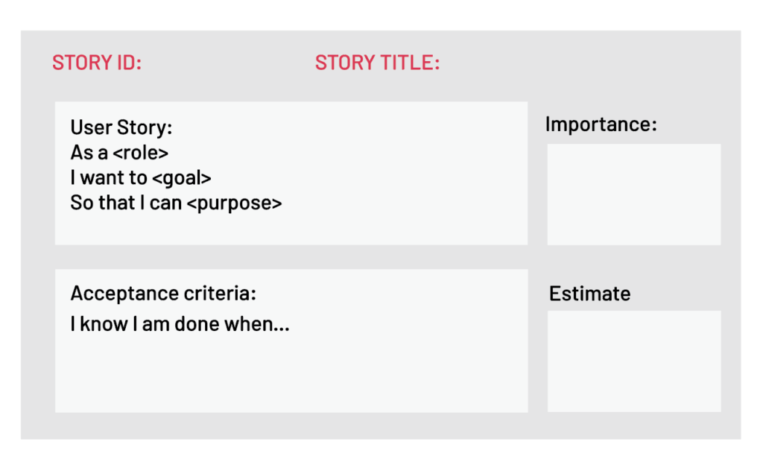
A User Story describes a desired feature (functional requirement) in narrative form. User Stories are usually written by the Product Owner, and are the Product Owner’s responsibility. The format is not standardized, but typically has a name, some descriptive text, references to external documents (such as screen shots), and information about how the implementation will be tested. For example, a Story might resemble the following:
Name: Planner enters new contact into address book, so that one can contact the person later by postal or electronic mail
Description: Planner enters standard contact information (first and last name, two street address lines, city, state, zip / postal code, country, etc.) into contact-entry screen. One clicks “Save” to keep the data, and “Cancel” to discard data and return to previous screen.
How to test: Tester enters and saves the data, finds the name in the address book, and clicks on it. One sees a read-only view of the contact-entry screen, with all data previously entered.
The elements in this User Story are:
- Name: The Name is a descriptive phrase or sentence. The example uses a basic “Role-Action-Reason” organization. Another common style, popularized by Mike Cohn, follows the template “As a <type of user>, I want <some goal> so that <some reason>.” The choice of template is less important than having a workable standard of some kind.
- Description: This is a high-level (low-detail) description of the need to be met. For functional (user-facing) requirements, the description is put in narrative form. For non-functional requirements, the description can be worded in any form that is easy to understand. In both cases, the key is that the level of detail is modest, because the fine details are worked out during the implementation phase, in discussions between team members, product owners, and anyone else who is involved. (This is one of the core concepts of Scrum: Requirements are specified at a level that allows rough estimation of the work required to implement them, not in detail.)
- Screens and External Documents: If the Story requires user-interface changes (especially non-trivial ones), the Story should contain or link to a prototype of the changes. Any external documents required to implement the Story should also be listed.
- How to test: The implementation of a Story is defined to be complete if, and only if, it passes all acceptance tests developed for it. This section provides a brief description of how the story will be tested. As for the feature itself, the description of testing methods is short, with the details to be worked out during implementation, but we need at least a summary to guide the estimation process.
There are two reasons for including the information about how to test the Story. The obvious reason is to guide development of test cases (acceptance tests) for the Story. The less-obvious, but important, reason, is that the Team will need this information in order to estimate how much work is required to implement the story (since test design and execution is part of the total work).

Story
Not all requirements for new development represent user-facing features, but do represent significant work that must be done. These requirements often, but not always, represent work that must be done to support user-facing features. We call these non-functional requirements “Technical Stories.” Technical Stories have the same elements as User Stories, but need not be cast into narrative form if there is no benefit in doing so. Technical Stories are usually written by Team members, and are added to the Product Backlog. The Product Owner must be familiar with these Stories, and understand the dependencies between these and User Stories in order to rank (sequence) all Stories for implementation.

Defect
A Defect, or bug report, is a description of a failure of the product to behave in the expected fashion. Defects are stored in a bug-tracking system, which may or may not be physically the same system used to store the Product Backlog. If not, then someone (usually the Product Owner) must enter each Defect into the Product Backlog, for sequencing and scheduling.

What are the Scrum roles?
The three roles defined in Scrum are the ScrumMaster, the Product Owner, and the Team (which consists of Team members). The people who fulfill these roles work together closely, on a daily basis, to ensure the smooth flow of information and the quick resolution of issues.

ScrumMaster
The ScrumMaster (sometimes written “Scrum Master,” although the official term has no space after “Scrum”) is the keeper of the process. The ScrumMaster is responsible for making the process run smoothly, for removing obstacles that impact productivity, and for organizing and facilitating the critical meetings. The ScrumMasters responsibilities include
- Teach the Product Owner how to maximize return on investment (ROI), and meet his/her objectives through Scrum.
- Improve the lives of the development Team by facilitating creativity and empowerment.
- Improve the productivity of the development Team in any way possible.
- Improve the engineering practices and tools so that each increment of functionality is potentially shippable.
- Keep information about the Team’s progress up to date and visible to all parties.
In practical terms, the ScrumMaster needs to understand Scrum well enough to train and mentor the other roles, and educate and assist other stakeholders who are involved in the process. The ScrumMaster should maintain a constant awareness of the status of the project (its progress to date) relative to the expected progress, investigate and facilitate resolution of any roadblocks that hold back progress, and generally be flexible enough to identify and deal with any issues that arise, in any way that is required. The ScrumMaster must protect the Team from disturbance from other people by acting as the interface between the two. The ScrumMaster does not assign tasks to Team members, as task assignment is a Team responsibility. The ScrumMaster’s general approach towards the Team is to encourage and facilitate their decision-making and problem-solving capabilities, so that they can work with increasing efficiency and decreasing need for supervision. The goal is to have a team that is not only empowered to make important decisions, but does so well and routinely.

Product Owner
The Product Owner is the keeper of the requirements. The Product Owner provides the “single source of truth” for the Team regarding requirements and their planned order of implementation. In practice, the Product Owner is the interface between the business, the customers, and their product related needs on one side, and the Team on the other. The Product Owner buffers the Team from feature and bug-fix requests that come from many sources, and is the single point of contact for all questions about product requirements. Product Owner works closely with the team to define the user-facing and technical requirements, to document the requirements as needed, and to determine the order of their implementation. Product Owner maintains the Product Backlog (which is the repository for all of this information), keeping it up to date and at the level of detail and quality the Team requires. The Product Owner also sets the schedule for releasing completed work to customers, and makes the final call as to whether implementations have the features and quality required for release.

Team
The Team is a self-organizing and cross-functional group of people who do the hands-on work of developing and testing the product. Since the Team is responsible for producing the product, it must also have the authority to make decisions about how to perform the work. The Team is therefore self-organizing: Team members decide how to break work into tasks, and how to allocate tasks to individuals, throughout the Sprint. The Team size should be kept in the range from five to nine people, if possible. (A larger number make communication difficult, while a smaller number leads to low productivity and fragility.) Note: A very similar term, “Scrum Team,” refers to the Team plus the ScrumMaster and Product Owner.

